
NORTHERN EDUCATION DIVISION MOCK EXAMINATION

2026 MALAWI SCHOOL CERTIFICATE OF EDUCATION

GEOGRAPHY

Subject Number: M073/I
Wednesday, 25th March Allowed: 2 ½hours
8:00-10:30am
PAPER I
(100 marks)
MAP READING AND PHYSICAL GEOGRAPHY

INSTRUCTIONS
- This paper contains 11printed pages, please check.
- This paper has two sections, A and B. Answer all the questions in the spaces provided.
- Write your name on all pages.
- In the table provided on this page, tick against the question number you have answered.
- At the end of the examination, hand in
your paper to the invigilator.

Question  Number | Tick if  Answered | Do not write in  these columns
1
2
3
4
5
Total

SECTION A (75 MARKS)
Answer all questions in the spaces provided.
- Study the 1:50 000 map extract of LILONGWE 1433B1 MG2019 and use it to answer questions that follow:
- (i). Identify the riverine feature found at six grid reference 721348.
____________________________________________________ (1 mark)
(ii) Find the six-figure grid reference for the trigonometric station 123 MWT.
________________________________________________ (2 marks)
- Name any one river which is displaying trellis drainage pattern on the map.
____________________________________________________________ (1mark)
- (i) In which direction is Chimakuwi river flowing?
_______________________________________________________ (1 mark)
(ii) Calculate the bearing of borehole D96 from trigonometric point 23NYS.

(3 marks)
- (i) Are Mphunzi and Gunde 1 villages intervisible on the map?
________________________________________________________(1mark)
ii. Give reason for your answer.
________________________________________________________________________________________________________________________________________________ (2marks)
- Calculate the area covered by TA Malili on the map. Give your answer to the nearest square kilometer.

5marks
- With the evidence from the map explain any one human activity that is threatening the sustainability of Kamuzu Dam.
______________________________________________________________________________________________________________________ (2 marks)

- Enlarge the area covered by the map twice its original size between easting 65 to 67 and northing 28 to 30. (4marks)
On it show the following
  - D197 road (1mark)
  - Dzalanyama forest reserve (1mark)
  - New scale (1mark)



- a. Figure 1 shows the world crustal plates and their boundaries. Use it to answer the questions that follow:

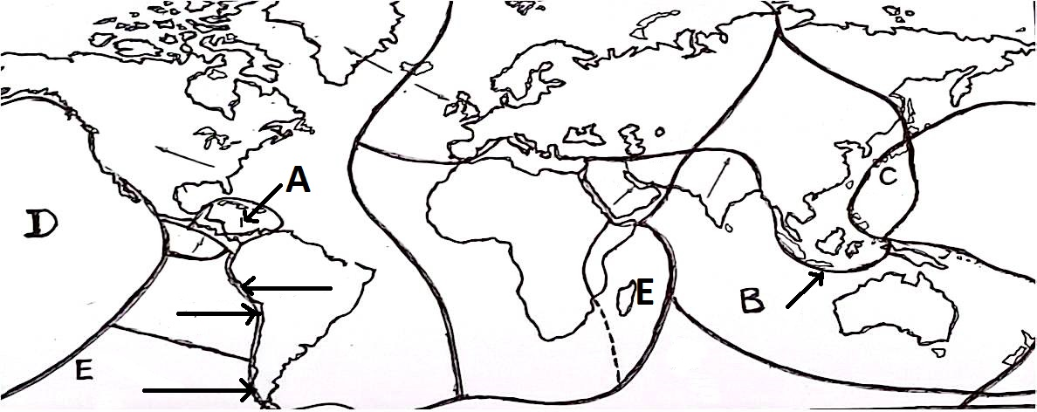

(i) Identify the crustal plates labeled A and C:
A ________________________________________________ (1mark)
C _________________________________________________________________ (1mark)
(ii) What type of crustal plates is crustal plate D?
____________________________________________________________________ (1 mark)
(iii) Mention any two geological features that form along convergent plate boundary.
________________________________________________________________________________________________________________________________________________ (2 marks)
(iv) Explain how feature E was formed.
____________________________________________________________________________________________________________________________________________ (2 marks)
b (i) Mention any two fold mountains in the Eurasian region.
______________________________________________________________________________________________________________________________________________ (2 marks)
(ii) Explain any two influence of Fold Mountains on the climate of the regions they are found.
______________________________________________________________________________________________________________________________________________________________________________________________________________________________ (4 marks)
c i. Briefly explain how arcuate delta is formed.
______________________________________________________________________________________________________________________________________________________________________________________________________________________________(3 marks)
ii. Mention any two negative influences of deltas.
_______________________________________________________________________________________________________________________________________________ (2 marks)
d i. Describe any two negative effects of earthquakes.
____________________________________________________________________________________________________________________________________________________________________________________________________________________________________________________________________________________________________________ (4 marks)
ii. State any two weather conditions associated with cumulus clouds.
__________________________________________________________________________________________________________________________________________________(2marks)
iii. Give any one example of higher level clouds.
____________________________________________________________________(1mark)
- a (i) Why are some ocean currents warm while others cold?
_______________________________________________________________________________________________________________________________________________ (2 marks)
(ii) Explain any two beneficial effects of ocean currents on human activities.
______________________________________________________________________________________________________________________________________________________________________________________________________________________________ (4 marks)
b) Figure 2 is a diagram showing the relief ocean basins. Use it to answer questions
that follow:
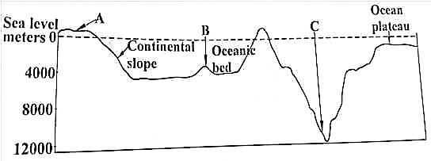
(i) Identify features labelled:
A. _____________________________________________ (1 mark)
B._______________________________________________ (1 mark)
(ii) Describe how feature labeled A is formed.
________________________________________________________________________________________________________________________________________________ (2marks)
c (i) State any two characteristics of igneous rocks.
_______________________________________________________________________________________________________________________________________________ (2 marks)
(ii) Explain how intrusive of igneous rocks how are formed.
____________________________________________________________________________________________________________(2 marks)
(iii) Give any one example of sedimentary rocks formed from plant remains.
_________________________________________________________________________________________________________ (1 mark)
(d) i. Using a diagram, describe the flow of air in cyclone in the Southern hemisphere.

2marks
____________________________________________________________________________________________________________(2marks)
ii. Why are the following conditions necessary for formation of cyclone?
- Warm water surface over 27 degrees Celsius. ____________________________________________________________________________________________________(1mark)
- Sufficient amount of Coriolis force. ____________________________________________________________________________________________ (1mark)
e i. Explain how the removal of vegetation influences climate change.
____________________________________________________________________________________________________________(2marks)
ii. State any two challenges of climate changes intervention measures.
____________________________________________________________________________________________________________(2marks)

SECTION B (25 MARKS)
Answer one question only in this section in the spaces provided.
- a Table 1 shows a climatic data collected at a certain weather station. Use it to answer questions that follow:
Month | J | F | M | A | M | J | J | A | S | O | N | D
Temperature | 20 | 22 | 25 | 30 | 32 | 33 | 31 | 30 | 30 | 30 | 30 | 30
Rainfall (mm) | 0 | 0 | 0 | 2 | 3 | 25 | 77 | 83 | 37 | 0 | 0 | 0

(i) Identify the type of climate for the station.
______________________________________________ (1 mark)
(ii) In which hemisphere is this climatic region? Give a reason for your answer.
___________________________________________________________________________________________________________ (2 marks)
(iii) Mention any two countries in Africa which experience the climate in table 1.
___________________________________________________________________________________________________________ (2 marks)
b (i) Describe any two characteristics of the climate in table 1.
_______________________________________________________________________________________________________________________________________________________________________________________________________________________________ (4 marks)
(ii) Explain any two factors which hinder economic development in this climatic in table 1.
_______________________________________________________________________________________________________________________________________________________________________________________________________________________________ (4 marks)
c i. Describe the movement of Inter – Tropical Convergence Zone.
______________________________________________________________________________________________________________________________________________________________ (2marks)
(ii) State any two effects of Inter Tropical Convergence Zone on the weather of Malawi.
___________________________________________________________________________________________________________ (2 marks)
d i. Using a well labelled diagram, describe how sea breeze occurs.

(3marks)
________________________________________________________________________________________________________________________________________________________________________________________________________________________________(3marks)
ii. State any two similarities among types of rainfall.
__________________________________________________________________________________________________________(2marks)
- a Figure 3 Shows mountain building process. Use it to answer questions that follow:
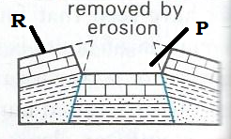

- What name is given to the feature labeled R and P:
R_____________________________________ (1mark) P________________________________________ (1mark)
- Name the type of fault associated with process in figure 3. ___________________________________________ (1mark)
- Explain the geographical force that is responsible for the development of the fault you have mentioned above. _______________________________________________________________________________________________(2marks)
- Briefly explain how the feature marked R is formed. ___________________________________________________________________________________________________________________________________________________________________________________________________(3 marks)
- i. Describe how ox bow lakes are formed.
________________________________________________________________________________________________________________________________________________________________________________________________________________________________________________________________________________________________ (3 marks)
(ii) State any two importance of ox bow lakes.
________________________________________________________________________________________________________________________________________________(2 marks)
c. (i) Draw an Isobaric diagram showing a high pressure area with the following readings: 1012mb, 1008mb,1004mb, 1000mb, 996mb and 992mb

(3marks)
(ii) Insert an arrow to show direction of winds on the pressure diagram in 5ci.
_____________________________________________ (1mark)
iii. Name any one example of Continental tropical air mass in Northern Africa.
______________________________________________(1mark)
  - i. Define the term air pressure.
____________________________________________(1mark)
ii. Account for the cause of air pressure patterns in the following belts:
- doldrums.
___________________________________________________________________________________________(2marks)
- polar regions.
__________________________________________________________________________________________(2marks)
iii. Describe any one difference between prevailing winds and local winds.
____________________________________________________________________________________________________________(2marks)

END OF QUESTION PAPER

